Step 1 : we need to upload the below files into our application:





Step 2 : Add new_SDKDependentOptionSetjs file to the form property of any entity

And bind to the onload event with passing the parameter as ‘new_systemsOpionsetConfigxml.js

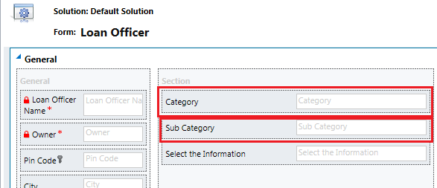

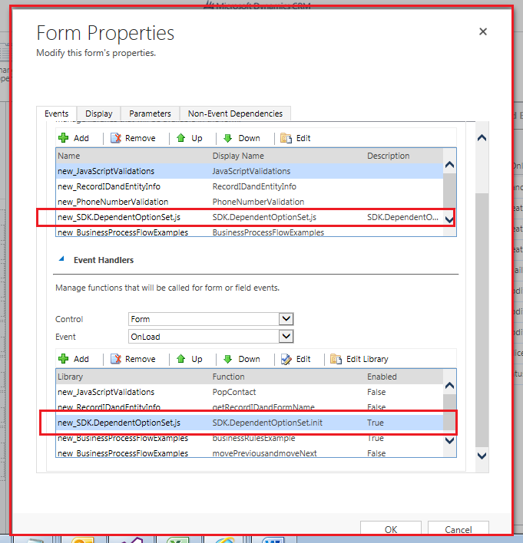

Click on Edit option as above mentioned and pass the parameter:

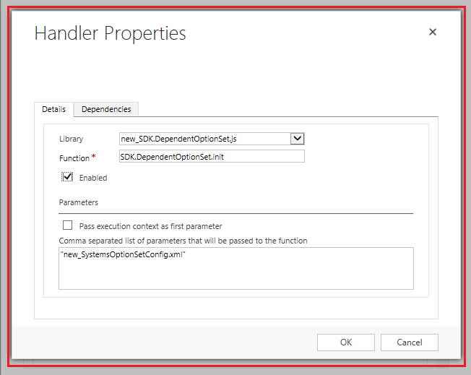

Then go to form properties and choose the category field :

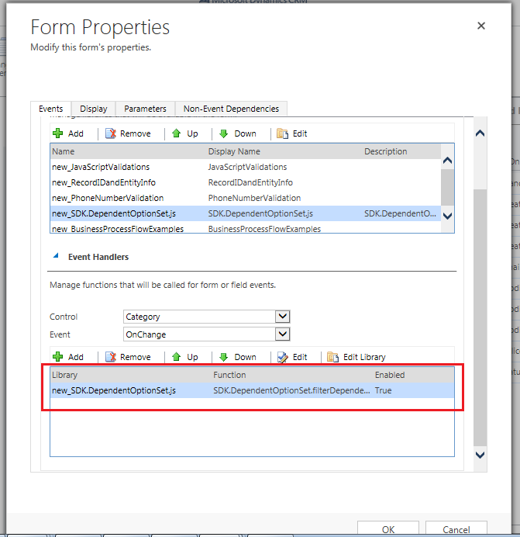

Click on Edit and the pass the fields

"new_category","new subcategory"

And function is: SDK.DependentOptionSet.filterDependentField

